

**Jordan University of science and technology**

**Computer Science Department**

**Milestone Writing Up**

**Students Name:**

**Eman Bataineh**

**Sumaya Rawashdeh**

**Supervised by:**

**Dr. Rania Zubaid**

**Prediction of pneumonia by using deep learning algorithms for pediatrics patient**

1. **Introduction:**

Pneumonia is a life-threatening infectious disease that affects one or both lungs in humans and is usually caused by either a bacterial” bacterium called Streptococcus pneumonia” or viral infection [1] fortunately, this bacterial or viral infectious disease can be well treated by antibiotics and antivirals drugs.

Pneumonia is one of the leading causes of death among the elderly and children in the world, where about 18% of all deaths in children under the age of five [2].

An accurate and fast diagnosis means everything [1], so early diagnosis of pneumonia is vital and any intervention that would affect pneumonia mortality is of great public health importance, where early diagnosis leads to correct medication and therefore can help significantly to prevent deterioration of the patient condition which eventually leads to death [3].

Chest X-rays are currently the best method for diagnosing pneumonia [4] Meanwhile, X-ray images of pneumonia are not very clear and often misclassified to other diseases or other benign abnormalities, which leads to wrong medication to the patients and thereby worsening the condition of the patient [3]. Also, there is a lack of trained radiologists in low resource countries (LRC), especially in rural areas. [1]Because automatic detection of pneumonia using digital x-ray images is urgently needed, Various Computer Aided Diagnostic (CAD) systems and computer algorithm diagnostic tools have been suggested by researchers to analyze X-ray images, where these suggested systems help radiologists identify different types of pneumonia with chest X-rays once they are gained.[5] Computer-Aided Designs (CAD) have come to be the major research domain in machine learning because CAD systems have already been displaying to facilitate the medical area. Machine Learning (ML) techniques were employed to medical images but because most of the algorithms used hand-crafted features for developing CAD systems based on examining images so the hand-crafted features with limitations varying according to tasks were not capable of supplying many meaningful features. As a result Employment of Deep Learning (DL) models particularly Convolutional Neural Networks (CNNs) discovered their self-potential of extracting useful features in image classiﬁcation tasks, Availableness of pre-trained CNN models like AlexNet [5], VGGNet [6], Xception [7], ResNet [8] and DenseNet [9] highly aid in the procedure of signiﬁcant feature extraction [7].

* **How the chest x-ray appears with pneumonia?**

When interpreting the x-ray, the radiologist will look for white spots in the lungs (called infiltrates) that identify an infection. Chest x-rays can reveal areas of opacity (seen as white) which represent consolidation.

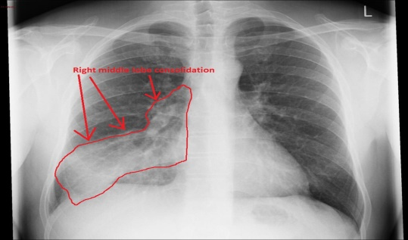 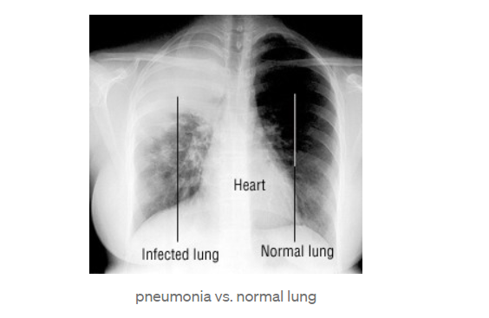

* 1. **Problem statement:**

The purpose is to implement effective diagnostic systems that can help classify and detect the presence of pneumonia from a set of chest X-ray samples using deep learning algorithms.

* 1. **Key words:**

Computer Aided Diagnosis, Convolutional Neural Networks ,Pediatrics Pneumonia, Chest X-ray, Deep learning, pneumonia detection

1. **Related works:**

Several methods have been used to help detect pneumonia using chest X-ray images. The authors in [3] develop and test a new computer-aided diagnosis (CAD) scheme of chest X-ray images to detect coronavirus (COVID-19) infected pneumonia, the images were processed, using a histogram equalization algorithm, and a bilateral low-pass filter. This image is fed into three input channels of a transfer learning-based convolutional neural network (CNN) model to classify chest X-ray images into 3 classes of COVID-19 infected pneumonia, other community-acquired no-COVID-19 infected pneumonia, and normal (non-pneumonia) cases, the dataset of 8,474 cases was randomly divided into 3 independent subgroups of training, validation, and testing, the overall classification accuracy levels for the three categories(COVID-19 infected pneumonia, other community-acquired no-COVID-19 infected pneumonia, and normal (non-pneumonia) cases) were 93.9% (796/848), 94.7% (803 / 848), and 94.9% (805/848), respectively, the results indicated that without using the data augmentation technique, the model's accuracy in the subgroup data drops to 82.3% with a kappa score of 0.71. Without applying image preprocessing and direct feeding of the original chest X-ray images into a VGG16-based CNN model, the classification accuracy is 88.0% with a kappa score of 0.75. Using pseudo-color filtering and imaging without removing the bulk of the diaphragm areas, the "filter dependent model" results in 91.2% accuracy and a Kappa-Cohen score of 0.83.

The researchers in [4] evaluate, visualize, and explain the performance of customized CNNs to detect pneumonia and further differentiate between bacterial and viral types in pediatric Chest X-Rays ,they presented a visualization strategy to localize the region of interest (ROI) that is considered relevant for model predictions across all the inputs that belong to an expected class(bacterial and viral), they used a set of Chest X-Ray for children includes anteroposterior Chest-Ray from 1 to 5 years of age, Normal (1349 training) and(234 test),Bacterial (2538 training) and(242 test),Viral (1345 training) and (148 test). They examined the dataset to remove unreadable, low-quality radiographs. The custom VGG16 model was observed to achieve 96.2% and 93.6% accuracy in detecting disease and distinguishing between bacterial and viral pneumonia. The model outperforms the state-of-the-art in all performance metrics and demonstrates reduced bias and improved generalization.

in [5], they developed an advanced deep learning-based architecture to detect pneumonia using chest X-ray images and utilized a convolutional neural network (CNN) based on VGG16 architecture consisting of 16 fully connected convolutional layers. The dataset contained 5,856 chest X-ray images were used for training, validating, and testing the model (normal = 1583, pneumonia = 4273) with a front view. The size of the images was 1024 x 1024 pixels. The model was based on CNN architecture along with various pre-processing techniques and parameters for fine-tuning. They reduced the size of the images to 224 x 224. The dataset was divided into 80% trained and 20% tested. The entire model was trained with Adam's Optimizer and Initial Learning Rate, the model's accuracy in validation and test sets was found to be approximately equal (96.5% and 96.6%, respectively).

The study of [8], they proposed an improved convolutional neural network (CNN) model for pneumonia detection. In order to guide the CNN to focus on the disease-specific attended region, the pneumonia area of image is erased and marked as a non-pneumonia sample. In addition, transfer learning is used to segment the interest region of lungs to suppress background interference. This model achieved 97.7% and 97.1% hashing accuracy with respect to the Montgomery and JavaScript Runtime (JSRT) datasets. SENet design was then used to fully optimize the CNN architecture. The presented detection models used are RetinaNet and Mask R-CNN. The Chest X-Ray image data set was obtained from the RSNA pneumonia detection challenge [14]. There were 8,964 pneumonia-class Chest X-Ray images, and the remaining 20,025 were non-pneumonia Chest X-Ray images. Three thousand Chest X-Ray images were used as test kits. The resolution of the R-CNN mask was 0.183, and the resolution of RetinaNet 0.225.

The authors in [6] proposed a deep convolutional neural network (CNN) based architecture, named as CovXNet, is proposed that utilizes depthwise convolution with varying dilution rates for efficiently extracting diversified features from chest X-rays for COVID-19, and they used a larger database containing X-ray images of normal pneumonia patients and other conventional pneumonia patients to initially train the deep network. It was observed that the stacking algorithm provides a further improvement in performance by optimizing the predictions obtained from CovXNet variants which are mainly optimized with different resolutions of the input X-rays. The generated activation map also provides differential identification of abnormal areas that can help diagnose differences in the clinical features of pneumonia in X-rays. The performance of these schemes could be improved by incorporating more X-ray samples of COVID-19 patients for training in the learning phase for transfer. The experimental results obtained from the extensive simulations indicated that it could be a very effective option for a faster diagnosis of COVID-19 and other pneumonia patients.

In [7], They demonstrate the feasibility of classifying the chest pathologies (include chronic obstructive pulmonary disease, pneumonia, asthma, tuberculosis, and lung diseases) in chest X-rays using conventional and deep learning approaches, they used 3(deep learning models) Convolutional Neural Network (CNN), Reverse Neural Network (BPNN) and Competitive Neural Network (CpNN) methodologies to classify chest X-ray diseases. The designed CNN, BPNN, and CpNN were trained and tested using chest X-ray images containing various pathologies. Many experiments were conducted by training these networks using different educational standards and a number of iterations. It was noted that the 32 x 32-pixel input image showed good performance and achieved high discrimination rates. CNNs were also trained and tested with a large dataset which was also used to train and test BPNN and CpNN. After convergence, it was observed that CNN was able to gain better generalizing power than that achieved by BPNN and CpNN, although the computation time required and the number of iterations was approximately higher. This superior performance is mainly due to the deep structure of CNN which uses the extraction power for different level features, resulting in better generalization ability. The proposed CNN simulation result was also compared with other CNN deep models such as GIST, VGG16, and VGG19. These networks have lower generalization capabilities and accuracy compared to the proposed network. The results obtained showed the high recognition rates of the proposed CNN.

In [1], they evaluate the functionality of pre-trained CNN models utilized as feature-extractors followed by different classifiers for the classification of abnormal and normal chest X-Ray specifically to detect Pneumonia. They used the Kaggle databases used for X-RAY Images of 26,000 training images and 3,000 test images[15]. They did some processing where the images were converted to a more suitable (PNG) file format. Resolution reduced to 128 x 128 for efficient image processing. They used two methods. First, they ran the neural network to classify the pneumonia pictures versus the pneumonia-free pictures which were Model 1. This model resulted in high sensitivity but low specificity. They split the second model into three parts.

First, they used the neural network to classify normal (normal versus healthy) disturbing images. This model was called the 2A. Then they used the neural network to distinguish between blurred pictures and pneumonia, and opaque images but without pneumonia. This model was called 2B. Then they ran 2A and used images that rated 2A opacity images as input for 2B, which were further categorized between pneumonia and no pneumonia in the images identified as unhealthy by 2A. Model 1 achieved 78.5% accuracy, Model 2A 68.5%, Model 2B 69.

Khalid EL ASNAOUI et al [9], used the chest X-Ray(the image dimension (244x244) & CT dataset (composed of 5856 images (jpeg format) and has two categories (4273 pneumonia and 1583 normal)), to do a comparison between DCNN techniques and other deep learning techniques for automatic binary classification of x-ray images between normal and pneumonia, they design fined tuned versions of (VGG16,VGG19, DenseNet201, Inception_ResNet_V2, Inception_V3, Xception, Resnet50, and MobileNet_V2), the chosen criteria for these techniques were based on the high accuracies, they considered it the best , they have used fine-tuned for the top layer of the DL techniques (CNN, VGG16, VGG19, DenseNet201, Inception_ResNet_V2, Inception_V3, Xception, Resnet50, and MobileNet_V2), and compare the performance of these techniques, also they used weight decay and regularizes L2 to avoid over-fitting, the results from this study show that the Resnet50, MobileNet_V2 and Inception_Resnet_V2 gave highly performance (accuracy is more than 96%) against other architectures that mention above (accuracy is around 84%).

On the other hand, because CNN need a large set of data to work effectively and the performance on a small data set needs some consideration so Vikash Chouhan et al[10] conducted a novel approach of transfer learning using pre-trained architectures trained on ImageNet to achieve the same accuracy for classifying chest x-ray to normal or pneumonia by using a small data set, they did a preprocessing and augmentation for the x-ray images (The dataset contains a total of 5232 images, where 1346 images belong to the Normal category, 3883 images depicted Pneumonia), also transfer learning using AlexNet, DenseNet121, InceptionV3, resNet18, and GoogLeNet neural networks, and feature extraction and ensemble classification done, the result that they get from this study that they can use an ensemble model that used all five pre-trained models and outperformed all other models. And they found that performance could be improved further, by increasing dataset size, using a data augmentation approach, and by using hand-crafted features.

Zhenjia Yue et al [11] according to classify the chest x-ray as normal and pneumonia they applied five mainstream network algorithms ( MobileNet which applies 3 × 3 depthwise separable convolutions that can greatly reduce the amount of computational cost, a regular CNN, ResNet-18, and two mainstream CNN models pre-trained on ImageNet ResNet 50 and VGG19), and compared the results, the dataset which they used are 5840 X-ray images (JPEG) and 2 categories (pneumonia/normal) related to pediatric patients of one to five years old, they conclude that all five network structures have the ability to recognize pneumonia and the accuracy of MobileNet is higher than other network structures.

Abdullah-Al Nahid et al [12] they proposed to use a novel ML method for Pneumonia detection while using a multi-channel CNN model .they used a CNN to extract global features from the X-ray images of the dataset, and used those features to detect the presence of Pneumonia in them. The CNN performs numerous convolution operations through-out the whole input image and, thus, extracts global features from the feature maps.

The dataset of chest X-ray images that they used containing both the Pneumonia-positive and Pneumonia-negative instances which contain a total of 5856 images. 4274 samples were collected from the patients with Pneumonia, whereas the rest of the images were collected from healthy subjects who did not have Pneumonia, cropping for images was done from the center in order to ignore unnecessary information outside of the chest-area and close to the border of the images. They explain that this step will help the algorithm to focus on the information relevant to this classification problem and to decrease the complexity of the algorithm. Another technique that applied to the image was the resized operation. The result that they achieved shows that the method is highly accurate in detecting the presence of pneumonia or not, based on the chest x-ray images.

Nada M. Elshennawy et al[13] , in their paper four different models are developed by changing the used deep learning method; two pre-trained models, ResNet152V2 and MobileNetV2, a Convolutional Neural Network (CNN), and a Long Short-Term Memory (LSTM). the model that they applied consists of two phases the first one responsible for image pre-processing, such as resizing, augmentation, data splitting, and data normalization the second phase works on feature extraction and image classification using different types of deep learning models. The dataset of chest X-rays in Kaggle was used, which consists of a total of 5856 images captured by a digital computed radiography (CR) system. 1583 of them are normal, and 4273 indicate pneumonia. they conclude that the proposed deep learning model ResNet152V2 which assessed based on the accuracy, precision, F1-score, recall, and AUC achieve the highest score compared with other models that achieved results of more than 91% inaccuracy, recall, F1-score, precision, and AUC.

1. **Materials and Method:**

In this research, we will work on supervised learning classification: (convolutional neural network algorithm). We will use a trained CNN template due to its effectiveness in identifying pneumonia from chest X-ray images and classifying images in the database into normal or pneumonia based on a number of features.

Convolutional Neural Network (CNN, or ConvNet) is a class of deep neuron networks, and it is most used in the classification and analysis of medical images for evidence of their efficiency and effectiveness in classifying and analyzing images ,CNN's use relatively little pre-processing compared to other images Classification algorithms. The images are classified by the convolutional nerve in a network framework that extracts the features from the images and classifies them.

**3.1 Dataset:**

In our study, we used a database of chest X-ray images (CXR) at Kaggle[15] . It contains 5856 JPEG images of children for classification of pneumonia, which is divided into two groups: the test group (normal 234 and pneumonia 390), the training group (normal 1349 and pneumonia 3883) as shown in Table 1: the images in the dataset.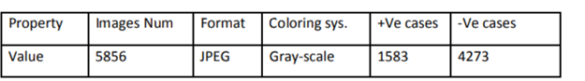

We divided the model images randomly into two parts (train and validation) and resize the images to our desired width and height in this case both being 224.

Figure 1 shows a healthy person without pneumonia while figure 2 shows a person with pneumonia

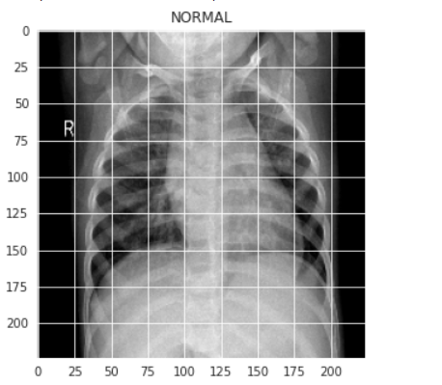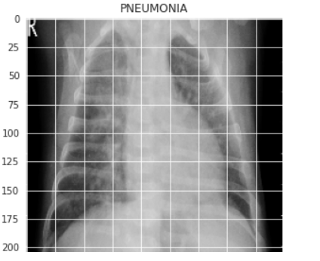

Figure1 Figure 2

We deployed Keras library for creating our model and training it. We also use Matplotlib and Seaborn for visualizing our dataset to gain a better understanding of the images we are going to be handling as in figure 3. Another important library to handle image data is Opencv.

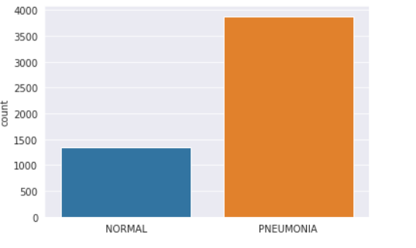

Figure 3: visualization of train dataset

**2.2 Image pre-processing**:

Preprocessing and Augmentation: The motivation behind image pre-processing is to improve the quality of visual information of each input image [4] Data augmentation is used for the training process after dataset pre-processing and splitting and has the goal to avoid the risk of over fitting [1] In this study We employed several data augmentation methods to increase quality of the dataset. the strategies we used rotation (denotes the range in which the images were randomly rotated during training), zoom ( Randomly zoom image) , width shift( randomly shift images horizontally) , height_shift ( randomly shift images vertically) , horizontal flip ( randomly flip images(to deal with the pneumonia symptoms on either side of the chest), vertical flip (randomly flip images) ,shear( clips the image angles in a counterclockwise direction),and finally augmenting images with brightness, the settings utilized in image augmentation are shown below in Table 2.

Figure (4) shows the effect of augmentation methods on the images

Table 2: data augmentation methods

|  |  |
| --- | --- |
| Technique | Setting |
| rotation | range = 90 |
| zoom | range = 0.5 |
| width_shift | range=0.1 |
| height_shift | range=0.1 |
| horizontal_flip | = True |
| vertical flip | =False |
| shear | range=0.35 |
| brightness | range=[0.1,0.5] |

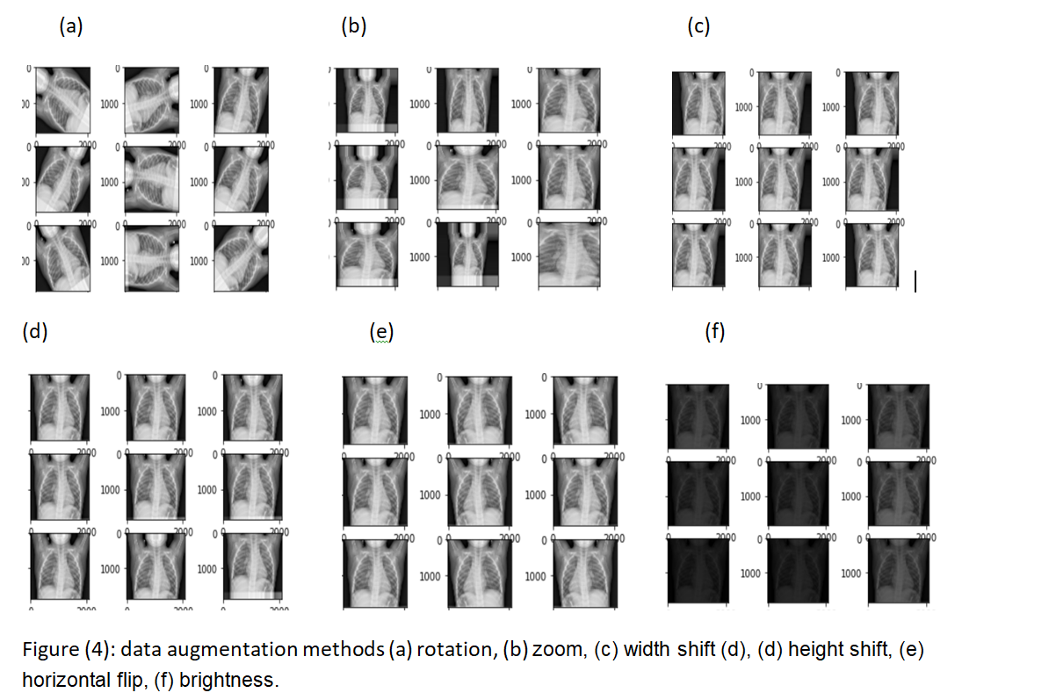

**2.3Proposed CNN architecture:**

The architecture of the proposed CNN model is designed with 3 Convolutional layers designed for two-dimensional input followed by max-pooling layers where pooling layers is a technique to down sample feature maps by summarizing the presence of features in patches of the feature map. There are two types of pooling methods that are average pooling and max pooling, we used Max pooling in order to calculate the maximum value in each patch for every feature map, A dropout layer is added after the 3rd max pool operation to avoid overfitting, we have used 4 ReLU layers for each convolutional layer and fully-connected layers that treats the input data as a simple vector and produces an output as a single vector. We have one inner-product layer in this model, the last one, a fully connected output layer with SoftMax activation for classification.

After that, we compile the model using Adam as an optimizer and Sparse Categorical Crossentropy as the loss function. We are using a lower learning rate of 0.000001 for a smoother curve. Then we train our model for 100 epochs since our learning rate is very small we will plot our training and validation accuracy along with training and validation loss.

**2.4 result:**

In this part, we present the result for the binary classification for the chest X-ray (normal, pneumonia) with deep learning frameworks, the Python programming language with the help of Keras was used for framework implementation and Google Colab was used in the GPU runtime in the training and validation phases.

after we choose the appropriate augmentation methods that used in the previous works and achieved a better result for the classification of chest x-ray [16],[17], the experiments and evaluation techniques used to test the efficiency of the proposed model were as following: CNN was trained for 100 epochs at the beginning then we decreased it to 50 epochs due to the long time the training process takes. We started with a learning rate = 0.1 and then trained at a very lower learning rate of 0.000001 for a smoother curve. Final results obtained are training loss = 0.1090, Training accuracy= 0.9656, validation loss= 0.4860, and validation accuracy =0.7965.

Figure (5) show the training and validation loss (overfitting)

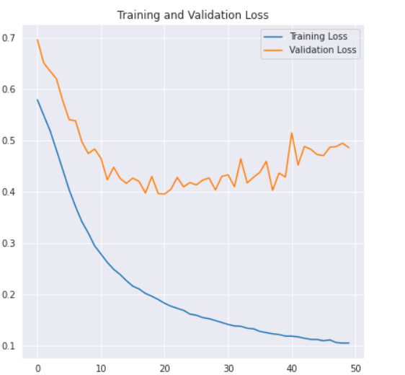

Figure (5)

**2.5 Discussion:**  We developed a model to detect and classify pneumonia from chest X-ray images at good validation accuracy. The algorithm started by transforming chest X-ray images into sizes smaller than the original. The next step includes the identification and classification of images by the convolutional neural network model, which extracts features from the images and classifies them, according to the result obtained from our model the amount of error at the validation set starts to increase while at the training set it continues to decrease, which indicate the possibility of overfitting that mean A model learns the training dataset too well, performing well on the training dataset but does not perform well on a holdout sample, so There are two ways to approach an overfit model by training the network on more examples or by changing the complexity of the network or we try to improve our model by using transfer learning we can easily achieve high performance. so our evaluation could be improved. There are some challenges that Encountered us and had a bad effect on our work which are our programming experience and technical issues, so in the next work we will focus on these issues to get better work.

**Conclusions:**

In this article, our goal is to propose effective diagnostic systems that can help classify and detect the presence of pneumonia from a set of chest X-ray samples using deep learning algorithms, final results obtained are training loss = 0.1090, Training accuracy= 0.9656, validation loss= 0.4860, and validation accuracy =0.7965. We observed that performance could be improved further, by increasing dataset size and using transfer learning to prevent overfitting, in the future.

Our findings support the belief that deep learning methods can be used to simplify the diagnostic process and improve disease management to enable patients to obtain early diagnosis and timely treatment, thereby reducing the mortality rate of pneumonia.

.

**References:**

1. Varshni, D., et al. Pneumonia Detection Using CNN based Feature Extraction. in 2019 IEEE International Conference on Electrical, Computer and Communication Technologies (ICECCT). 2019.
2. Elshennawy, N.M. and D.M. Ibrahim, Deep-Pneumonia Framework Using Deep Learning Models Based on Chest X-Ray Images. 2020. 10(9).
3. Heidari, M., et al., Improving the performance of CNN to predict the likelihood of COVID-19 using chest X-ray images with preprocessing algorithms. International Journal of Medical Informatics, 2020. 144: p. 104284.
4. Rajaraman, S. and S. Candemir, Visualization and Interpretation of Convolutional Neural Network Predictions in Detecting Pneumonia in Pediatric Chest Radiographs.2018. 8(10).
5. Shah, U., et al., An Efficient Method to Predict Pneumonia from Chest X-Rays Using Deep Learning Approach. Stud Health Technol Inform, 2020. 272: p. 457-460.
6. Mahmud, T., M.A. Rahman, and S.A. Fattah, CovXNet: A multi-dilation convolutional neural network for automatic COVID-19 and other pneumonia detection from chest X-ray images with transferable multi-receptive feature optimization. Computers in Biology and Medicine, 2020. 122: p. 103869
7. Abiyev, R.H. and M.K.S. Ma’aitah, Deep Convolutional Neural Networks for Chest Diseases Detection. Journal of Healthcare Engineering, 2018. 2018: p. 4168538.
8. Li, B., et al. Attention-Guided Convolutional Neural Network for Detecting Pneumonia on Chest X-Rays. in 2019 41st Annual International Conference of the IEEE Engineering in Medicine and Biology Society (EMBC). 2019.
9. Asnaoui, K. E., Chawki, Y., & Idri, A. (2020). Automated methods for detection and classification pneumonia based on x-ray images using deep learning. arXiv preprint arXiv:2003.14363.‏
10. Chouhan, V., Singh, S. K., Khamparia, A., Gupta, D., Tiwari, P., Moreira, C., ... & De Albuquerque, V. H. C. (2020). A novel transfer learning based approach for pneumonia detection in chest X-ray images. Applied Sciences, 10(2), 559.‏
11. Yue, Z., Ma, L., & Zhang, R. (2020). Comparison and Validation of Deep Learning Models for the Diagnosis of Pneumonia. Computational Intelligence and Neuroscience, 2020.‏
12. Nahid, A. A., Sikder, N., Bairagi, A. K., Razzaque, M., Masud, M., Z Kouzani, A., & Mahmud, M. A. (2020). A novel method to identify pneumonia through analyzing chest radiographs employing a multichannel convolutional neural network. Sensors, 20(12), 3482.‏
13. Elshennawy, N. M., & Ibrahim, D. M. (2020). Deep-Pneumonia Framework Using Deep Learning Models Based on Chest X-Ray Images. Diagnostics, 10(9), 649.‏
14. <https://www.kaggle.com/c/rsna-pneumonia-detection-challenge>
15. <https://www.kaggle.com/paultimothymooney/chest-xray-pneumonia>
16. Hussain, Z., Gimenez, F., Yi, D., & Rubin, D. (2017). Differential data augmentation techniques for medical imaging classification tasks. In *AMIA Annual Symposium Proceedings* (Vol. 2017, p. 979). American Medical Informatics Association.‏
17. Buslaev, A., Iglovikov, V. I., Khvedchenya, E., Parinov, A., Druzhinin, M., & Kalinin, A. A. (2020). Albumentations: fast and flexible image augmentations. *Information*, *11*(2), 125.‏